

Department of Computer Science and Engineering

Course Code: CSE464

Course Title: Advance Database

Section: 02

Semester: Fall 24

**LAB-3 Assignment**

**Submitted to:**

**Khairum Islam**

Lecturer

Department of Computer Science and Engineering

East West University

**Submitted by:**

**Name:** B. M. Shahria Alam

**ID:** 2021-3-60-016

**Date of submission:** 30 November, 2024.

**1. WAP to delete the data for employees after entering job.**

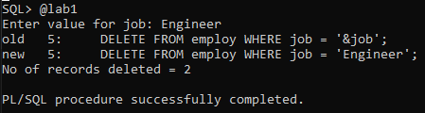

**2. WAP to increase the sat for employees by 1000 rs. For deptno=10.**

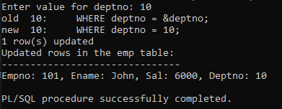

**3. This PL/SQL block deletes rows from the emp table for a given job title and outputs the number of rows deleted.**

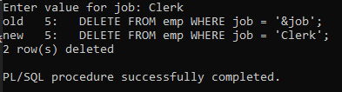

**4.**

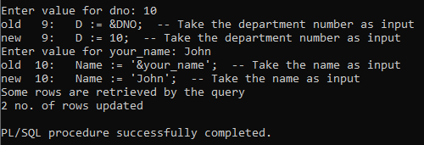

**5.WAP to insert the data of the clerks from emp table to another table**

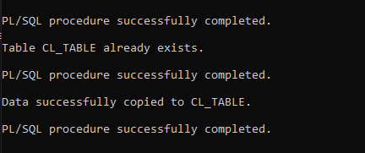

**EXERCISE 1:**

BEGIN

EXECUTE IMMEDIATE 'CREATE TABLE del_history (

deptno NUMBER(3),

deleted_count NUMBER(5),

deletion_date DATE

)';

EXCEPTION

WHEN OTHERS THEN

IF SQLCODE = -955 THEN

DBMS_OUTPUT.PUT_LINE('Table del_history already exists.');

ELSE

DBMS_OUTPUT.PUT_LINE(SQLERRM);

END IF;

END;

/

DECLARE

deleted_count NUMBER(5);

BEGIN

DELETE FROM emp WHERE deptno = 50;

deleted_count := SQL%ROWCOUNT;

IF deleted_count > 0 THEN

DBMS_OUTPUT.PUT_LINE(deleted_count || ' rows deleted from department 50.');

INSERT INTO del_history (deptno, deleted_count, deletion_date)

VALUES (50, deleted_count, SYSDATE);

COMMIT;

ELSE

DBMS_OUTPUT.PUT_LINE('No rows deleted from department 50.');

END IF;

DELETE FROM emp WHERE deptno = 20;

deleted_count := SQL%ROWCOUNT;

IF deleted_count > 0 THEN

DBMS_OUTPUT.PUT_LINE(deleted_count || ' rows deleted from department 20.');

INSERT INTO del_history (deptno, deleted_count, deletion_date)

VALUES (20, deleted_count, SYSDATE);

COMMIT;

ELSE

DBMS_OUTPUT.PUT_LINE('No rows deleted from department 20.');

END IF;

END;

/

SELECT * FROM del_history;

